**Question 2**

2**. Write a program that displays a list of products in a window. But once a significant number of products have been sold, you might want to display the products in a table along with their sales figures. Further, let’s suppose that we need to produce two kinds of displays from our product data, a customer view that is just the list of products we have mentioned and an executive view that also shows the number of units shipped.**

**2.1. Display products in alphabetical order, if requested by user.**

**Pattern Used:** Bridge Pattern

**Why Use This Pattern**

Bridge is used when we need to decouple an abstraction from its implementation so that the two can vary independently. This type of design pattern comes under structural pattern.

Since we have two different views the customer with displays the list of product name in a list view and the executive view which displays the product name together with it quantity sold using a table view from our product data.

Creating a bridge class:

* Help us separate this two view so that they can be independently modified without affecting the other.
* Keeps the interface to your client program constant while allowing you to change the actual kind of class display or use?
* hide implementation details from the client program much more easily.

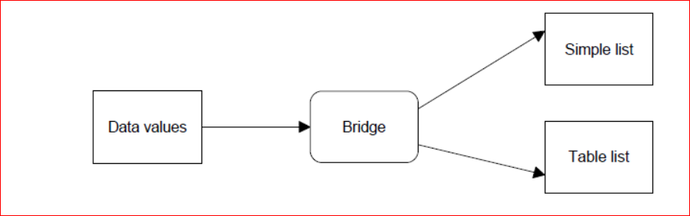**d**

**Class Diagram**

